**ADTA-5550: Assignment 4 – Convolutional Neural Network**

**Part I:**

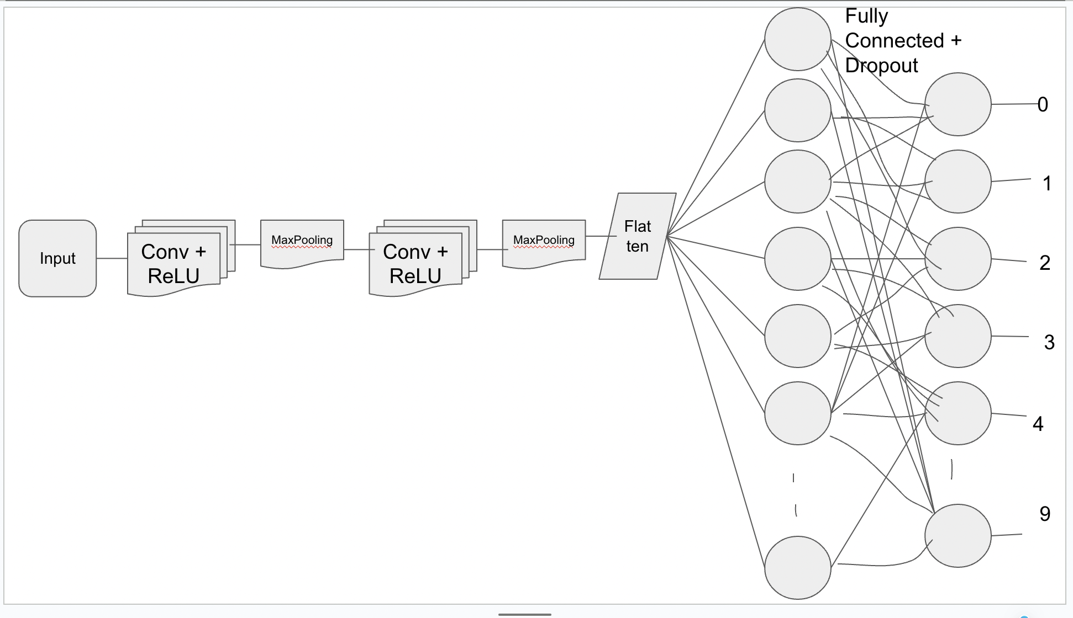

(image created in google slides)

In this section, I have created 2 layered convolution, ReLU with 2 levels of pooling. I have used max pooling in this model. Later the output of 2nd layer pooling is flattened and provided to fully connected layer with SoftMax activation function. I have also implemented dropout with 0.5 probability. Later, I collected the output at the respective node from 0 to 9.

I have trained this model with 5000 steps. Finally evaluated the model on test dataset. The model have provided the test accuracy as 0.9884 (98.84%). Which is really good for prediction.

**Part II: Only 1 Convolution Layer**

(image created in google slides

Image showing step size as 5001 to consider 5000th step I have taken 5001 as the step count.

In this section, the have redesigned the previous model to have only 1 convolution layer. The output of the CONV layer is applied to flattening layer then I have connected it to fully connected layer with SoftMax function and dropout function.

After training the model with 5000 steps, the model has resulted the test accuracy as **0.986.**

**Part III – only one convolution layer with 3000 steps:**

Image showing step size as 3001 to consider 3000th step I have taken 5001 as the step count.

After re-training the previous model with 3000 steps, the above results shows that accuracy is **0.9798** at 3000th step.